LUCI Messaging Guide
For internal use — sales, marketing, and client-facing communications

HOW TO USE THIS DOCUMENT
Pull from this when you’re writing anything external — emails, decks, proposals, LinkedIn posts, event copy. The tagline and value prop are exact; use them as written. For the deeper philosophy behind this messaging, see the LUCI Philosophy document.
TAGLINE
The Smarter Platform for Enterprise Multimedia
Control, automate, and manage every A/V system from a single interface
VALUE PROPOSITION & BOILERPLATE
Use this as standard language for emails, decks, and proposals.

LUCI is the operating system for complex properties — one platform that unifies every A/V, signage, building, and operational system into a single interface your team controls from anywhere so you can strategically activate the guest experience.
THE LUCI WORLDVIEW
Complex environments don’t fail because of what they lack. They fail because of what they accumulate.
Every property runs on a stack of vendors, processors, interfaces, and workarounds that each made sense at the time, but create downstream challenges.
LUCI doesn’t address this with an additional tool; it addresses this with the principle of subtraction. By removing variables. Its success is evidenced by the number of things our clients no longer have to think about.
THE OFFERING
LUCI is a fully managed A/V operating platform — software, hardware, operating model, and an embedded engineering team — deployed as a complete system your team takes over from day one. Every engagement runs on the LUCI Playbook, our accumulated institutional knowledge refined across every deployment.

SOFTWARE PLATFORM | A continuously developed operating platform that binds every A/V endpoint and system across your property into one interface
HARDWARE ARCHITECTURE | Standard network infrastructure with a minimal footprint that eliminates the proprietary racks and refresh cycles required by traditional A/V
OPERATIONAL MODEL | Built-in access controls, change management, and incident resolution, durable through staff turnover and property expansions
DELIVERY MODEL | LUCI FDE — the same seasoned engineers from day one through year five, with no handoffs
THE LUCI PLAYBOOK | The set of software, hardware decisions, network architecture, integration patterns, and operational practices that bind the LUCI platform and its delivery.

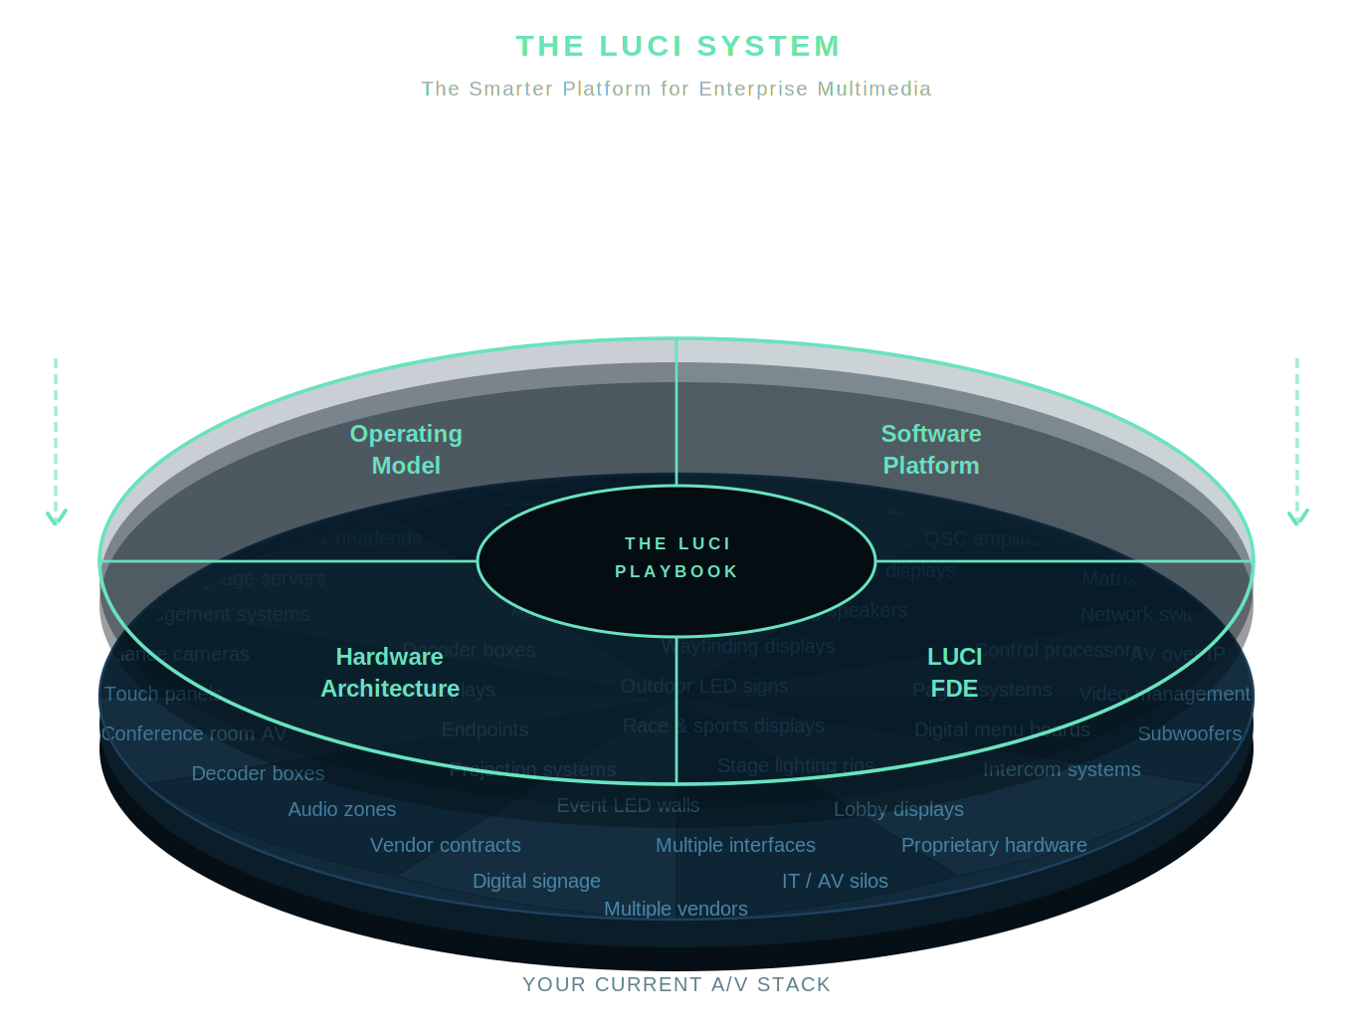

Our four commitments
01 — Support begins before deployment.
Every LUCI engagement starts with the FDE team embedded in the property. Support begins on day one.
02 — The team that builds your system is the team that supports it.
The engineer who walks the property on day one is the engineer who answers the call in year five.
03 — One team owns every incident, end to end.
There is no ticket queue, no escalation path, no third party. LUCI owns diagnosis and resolution.
04 — The platform gets more capable every day.
Continuous refinement means every release, every engagement, every year adds capability.

MESSAGE PILLARS
Four pillars that anchor every communication. Each stands alone and serves any buyer.
01 Complete visibility and control across your property
One interface surfaces every endpoint, zone, and system across your property. Every team sees the same picture and acts from the same place.
02 Align your teams by default
LUCI connects every team to the same system, so your organization can stop negotiating internally and start executing towards a shared vision.
03 Fully activate the guest experience
Turn passive screens into purposeful moments by planning, programming, and responding to guest signals in real time — turning your A/V infrastructure into a strategic tool for revenue, retention, and brand.
04 Invest in the only A/V that gets more valuable over time
Traditional A/V depreciates and expires. LUCI doesn’t. We refine our software, integrations, and operational capability on a predictable annual line item so Year Five is more capable than Year One.
WHO HEARS WHAT
Lead with the pillar most relevant to the person in the room.

CEO / GM  Pillars 01 + 03  Full property visibility, guest experience as a strategic output. | CIO / IT Director  Pillars 01 + 04  Standard infrastructure, open APIs, no proprietary hardware to manage or refresh. | COO / Operations Director  Pillars 01 + 02  One control layer, one accountable team, incidents owned end-to-end.
CFO  Pillar 04  Predictable annual line item, no refresh cycles, investment that compounds over time. | CMO / Marketing Director  Pillar 03  Real-time programmability across every zone, screen, and guest moment. | A/V Manager / Director  Pillars 01 + 04  Complete property visibility, a platform that grows more capable every year.

KEY FEATURES

Map-based dashboard  Live visual map of every display, audio zone, and system endpoint across the property | Open API integration  Connects to any A/V, signage, building, or content system | Intelligent triggers & automation  Schedule scenes in advance or fire coordinated A/V responses to real-time events
PIN-delegated control  Every user controls only their designated zones | Predictive monitoring & alerts  System surfaces and resolves common issues automatically, before the guest notices | Continuous platform development  Ships on a regular cycle — no capital projects, no refresh cycles
Mobile control from any device  Full property control from any authorized device, on or off property | Scalable by architecture  Add venues, floors, or sister properties without replacing the core — the platform extends, it doesn’t rebuild.
WHAT LUCI IS AND ISN’T

LUCI IS  - An operating system that connects infrastructure  - Software, hardware, operating model, and embedded engineering — delivered as one system  - A platform that appreciates over time  - A team of seasoned engineers accountable from design through ongoing refinement | LUCI IS NOT  - A control panel (runs one system at a time)  - A dashboard (reports on a property, doesn’t operate one)  - A point solution that creates an integration problem  - A vendor that hands off after deployment

VOICE & TONE GUIDELINES
These rules apply to everything LUCI publishes — website, decks, proposals, outreach, social, video. If a piece of copy doesn’t pass these rules, it doesn’t go out.
Voice rules
Institutions, not adjectives.
Describe what the platform does for the enterprise. Never describe how the software feels to use. “Operate every endpoint from one interface” passes. “Absurdly simple” does not.
Subtraction over addition.
Lead with what LUCI removes from the environment — variables, vendors, interfaces, refresh cycles — not with the capabilities it adds.
Declarative over promotional.
State facts. Avoid emotional verbs (“revolutionize,” “transform,” “empower”). If a claim needs an adverb to land, it isn’t landing. Cut.
Discretion over display.
No client names in public materials. No percentage claims. Scale and complexity are described in general terms.
Standardization is the advantage.
Never apologize for a standard approach. Standardization is what makes the system reliable. Customization is what broke every A/V environment they’ve had before.
Short sentences. Short paragraphs.
If a claim needs a modifier to land, it isn’t landing. Cut the modifier. Then cut the sentence it was propping up.
Proof & institutional trust
When describing LUCI’s scale, scope, and track record, use language that conveys depth without naming clients or citing specific metrics. These are the approved frames:

SAY THIS  - Deployed across complex, high-traffic properties  - Refined through years of operational engagement  - Built on institutional knowledge accumulated across the portfolio  - Tested against the demands of 24/7 enterprise environments  - Trusted by properties that cannot afford failure | NOT THIS  - Specific client names or logos  - Percentage reduction or uptime claims  - Named properties or locations  - Revenue impact figures  - Headcount or team size specifics

Approved language
Use these terms consistently across all materials.

USE THESE  - Infrastructure, platform, operating system, operating layer  - Institutional, operational, embedded, accountable, continuous  - The Playbook, LUCI FDE, the engagement model, the standard  - Runs, operates, integrates, consolidates, refines  - Removes variables, shorter list, fewer moving parts | RETIRE THESE  - Absurdly simple / easy to use / intuitive — consumer register  - Revolutionize / transform / empower — empty emotional verbs  - Any percentage reduction or increase claim in brand-level copy  - Owner’s rep — use LUCI FDE or embedded team  - Best-in-class / game-changing / conversation-stoppers — pitch-deck language  - Named clients in public materials
By medium
The register shifts by context. The principles never do.

Website & sales collateral — Insightful and precise
Lead with the variable-reduction principle. Name the systems LUCI replaces. State what the platform does for each team. No emotional verbs, no percentage claims. Every sentence should be provable.
Executive pitches & proposals — Authoritative and operational
Open with the problem — accumulation, not lack. Build to the platform as the institutional solution. Let the FDE model and the four commitments close. Speak to the CFO, CIO, and COO simultaneously.
Email & client outreach — Direct and specific
One idea per email. Name the person’s specific problem before naming LUCI. Never open with a feature. Open with a consequence of not having LUCI — a downstream question they’re currently answering that they shouldn’t have to.
Social content — Declarative and confident
Short. Declarative. One idea per post. The worldview is the content — a well-placed sentence from the philosophy section will outperform any product announcement. No hyperbole.
Video & presentations — Conversational but grounded
Anchor to the philosophy before introducing the product. The variable-reduction principle lands well on camera. Use the anchor phrases below. Speak in problems and consequences, not capabilities.

For the philosophy, principles, and full platform narrative that underpin this messaging, see the LUCI Brand Voice & Philosophy Reference.

